Sponsor Information Packet

The Thai Your Shoes Foundation Presents:
The 4th Annual Race for Sincere Hearts 5K Run/Walk
Saturday, May 26th, 2012 9:00am
Proceeds Benefit Baan Jing Jai children’s home in Pattaya, Thailand

The Thai Your Shoes Foundation is busy making plans for the fourth annual Race for Sincere Hearts 5K Run/Walk, which will be run on May 26th, 2012. This run/walk has grown each year and is a success because of the support of our sponsors. Your potential sponsorship of this event will ensure its continued success in improving the lives of over 80 impoverished children in Pattaya, Thailand. This year we are hoping to raise, in combination with our sister race in Nashville, TN, a total of $5000, which would help to build a new music room for the children at Baan Jing Jai.
The cost of advertising is high, and with a race sponsorship, not only do you get your company’s name on the back of each race t-shirt, you get your company name listed on our web site, and advertising through our race goody bags as well as any signs displayed throughout the area. You get to put coupons, business cards, and flyers—whatever you want—to promote your business in the race package that each runner/walker receives. What better way to promote your business in the community than showing your support for an important cause while spreading word of your business for a fraction of what costs would normally be?
Please find attached an outline of the sponsorship levels for our race. In return for your financial sponsorship, we offer you promotion of your company’s name through different mediums. Our race attracts competitors from the north and northwest suburbs. It is advertised and sanctioned by USA Track & Field (www.usatf.org) as well as on the race calendar at www.runnersworld.com, a nationally recognized running magazine.
Please take time to review the attached sheets, and feel free to visit our web sites at www.rfsh.weebly.com for information about our organization and our race. We would also appreciate your questions or comments regarding your company’s interest in participating as one of our race sponsors. Please feel free to e-mail me at victoriarm19@aol.com, or call me personally at 847.691.0030 expressing your interest. I will get back to you with additional details and information.

Thai Your Shoes
Victoria Moroney, Palatine Race Director

The 2011 4th Annual 5K Run/Walk Race Facts

Event: Our 4th annual race features a 5K run/walk.

Date & Time: Saturday May 26th, 2012 at 9:00 in Deer Grove East Forest Preserve in Palatine, Illinois

Course: The race takes place in Deer Grove East forest preserve, following a winding bike path as well as grass trails that take you through the sights and sounds of the preserve.

Organizers: Lisa Koenig, now a sophomore at Vanderbilt University in Nashville, Tennessee, started The Thai Your Shoes foundation in 2008. After visiting Baan Jing Jai children’s home in Pattaya, Thailand she was inspired to help the children there in any way she could, starting with shoe drives, and moving onto larger fundraisers. Fremd graduate Victoria Moroney, now a freshman at Georgetown University, created the Race for Sincere Hearts in 2009 to continue supporting the children at Baan Jing Jai, and along with Lisa has organized and directed the race ever since.

Participants: Our event hosts almost 200 competitors, in addition to over 30 volunteers, plus spectators, which help make our event a success.

Amenities: All participants receive a goody bag, which includes a t-shirt and a list of all sponsors and other various items. Sponsors are also encouraged to put in an ad, a coupon good for their business, or even pens, pencils, or water bottles or other promotional item if you chose to promote your business that way. Medals go to the overall male and female winners, and 1st and 2nd place competitors in all age group categories.

Beneficiaries: The Thai Your Shoes Foundation had donated over $16,000 to Baan Jing Jai orphanage in addition to countless numbers of donations of shoes and clothing donated by the community.

Advertising: The race is promoted by advertising through race applications, flyers and other promotional items throughout the region. The race maintains its own web site www.rfsh.weebly.com. We are also featured on many online event calendars, such as Runner’s World and USATF.

Expenses: Expenses come from the cost of insurance, permits, t-shirts, awards, race bibs, food, advertising, course markers and other miscellaneous expenditures. A copy of the projected budget for 2012 is available upon request.
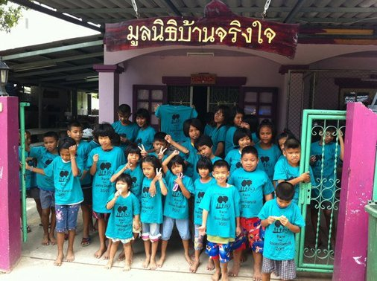
Sponsorship Packages 2011

Platinum Level Sponsor $150
- Your company name listed as Race for Sincere Hearts sponsor on all race ads and signs displayed throughout the area
- Your company’s name & logo listed on the back of race t-shirt (prominent position)
- Your company’s brochures/advertisements put into each racer’s race goody bag (around 200 expected racers)
- Listed as Race for Sincere Hearts platinum sponsor on official race & Thai Your Shoes websites, with links to your site
- Two free race entries
- Two official race t-shirts
Gold Level Sponsor $75
- Your company name listed as Race for Sincere Hearts sponsor on all race ads and signs displayed throughout the area
- Your company’s name & logo listed on the back of the race t-shirt
- Your company’s brochures or advertisements put into each racer’s race goody bag (around 200 expected racers)
- Listed as Race for Sincere Hearts gold sponsor on official race & Thai Your Shoes websites, with link to your site
- One official race t-shirt

For more information about sponsorship possibilities, contact Victoria Moroney.
Cell #: 847.691.0030
E-Mail: victoriarm19@aol.com
For general information about the Race for Sincere Hearts and the Thai Your Shoes organization, please visit:
www.rfsh.weebly.com
www.thaiyourshoes.weebly.com

